## 

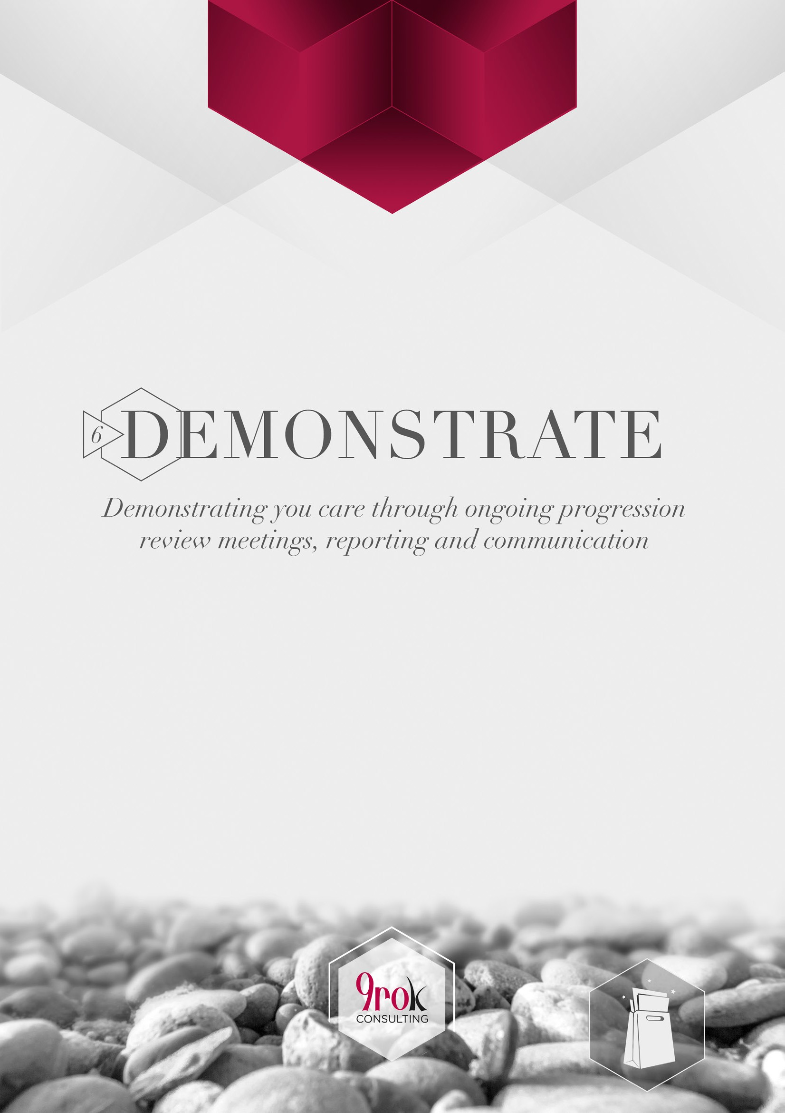

**STEP 6 - DEMONSTRATE**

### Demonstrating you care through ongoing progression review meetings, reporting and communication

Welcome to the final step in the Client Engagement Process Skills Goodie Bag.

‘Demonstrate’ is the sixth of six easy steps designed to help you support your advice business and streamline your client engagement process.

This step allows you to demonstrate your care for your client, through ongoing progression reviews meetings, reporting and regular communication over the duration of your relationship.

### What’s it all about?

Demonstrate provides you with a range of letters, preparation and team member guides, agenda and checklists for connecting with the client after they have engaged you as their advice partner.

It includes:

* Progress review meeting client information pack – four documents covering preparing for the progress review, letter, request form to update information and agenda
* Progress review meeting business information pack – three documents covering the entire process for greeting a client for the progress review meeting to the end, including two checklists and a team member guide.

### What’s in it for you?

This step also includes a letter:

* Follow up letter – the last document to be forwarded within 24 hours of the progress review meeting.

## 

|  |  |  |
| --- | --- | --- |
| **1.** | **DEMONSTRATE** | **TOOL TYPLE** |
| **Purpose** | Demonstrating you care through ongoing progression review meetings, reporting and communication. | |

### Progress review meeting client information pack

* + 1. Letter accompanying progress review information pack
    2. Request form to update personal/financial information
    3. Progress review meeting client preparation guide

Client comms Data collection

Client prep guide

* + 1. Agenda for progress review meeting Agenda



### Progress review ‘PR’ meeting business information pack

|  |  |  |  |
| --- | --- | --- | --- |
|  | **6.2.1** | Progress review meeting preparation | Checklist |
| **6.2.2** | Guide to progress review meeting | Team member guide |
| **6.2.3** | Checklist for greeting the client | Checklist |
| **6.2.4** | Follow up letter to progress review meeting | Client comms |
|  |  |  |  |

**TOOL 6.1.1:** Letter accompanying progress review information pack | Progress review meeting client information pack



**PURPOSE:** Client communication letter to accompany the ‘progress review meeting client information pack’. To be sent at least 21 days prior to the meeting.

*\*Client facing tool to be cut below the dotted line and embodied into personalised branded document*

# ………………………………………………………………

Dear *<first name>*,

RE: Keeping you on track and progressing in the right direction

Sometimes it’s only small changes that can make a big difference to how secure you feel about your financial future. With the constantly changing world we live in, it can be difficult to know how these changes impact your situation.

To ensure your advice and recommendations remain relevant and appropriate, it’s essential we meet to assess and review how you are tracking. This also allows us to identify any changes that need to be made and discuss relevant opportunities that are available to help improve your current and future position.

It’s also a great opportunity to discuss anything on your mind. In order to get the ball rolling, we’d like you to firstly have a think about anything that has changed in your situation or around your personal, business or financial goals.

<We have scheduled a meeting on *date/time>*.

*(Or if a meeting has not been scheduled include the following)*

I would like to arrange your next meeting in *<June>*. Here are some date and time options for your consideration:

◻ *Monday 14 June @ 3:00pm*

◻ *Wednesday 16 June @ 2:00pm*

◻ *Tuesday 22 June @ 2:00pm*

◻ *Thursday 24 June at 3:00pm*

Can you please let us know if any of the above dates and times suit? If not, please advise us of a more preferable alternative. Please allow up to <1.5> hours for this meeting.

**TOOL 6.1.1:** Letter accompanying progress review information pack | Progress review meeting client information pack



**PURPOSE:** Client communication letter to accompany the ‘progress review meeting client information pack’. To be sent at least 21 days prior to the meeting.

*\*Client facing tool to be cut below the dotted line and embodied into personalised branded document*

# ………………………………………………………………

The items we will cover in our meeting include:

1. To review any change in your personal and financial circumstances and how these may impact the advice currently in place.
2. To discuss and review your progress and make any necessary changes.
3. To outline any changes in legislation, economic, political or market conditions that may impact your situation; and
4. To provide you with the opportunity to raise any questions or concerns.

Please find attached a progress review meeting information pack to help you prepare for our catch up, including:

* Request form to update your personal/financial information-to be completed and returned at least seven days prior to our meeting
* Progress review meeting preparation guide; and
* Agenda for our progress review meeting.

In the meantime, please contact us if you have any questions prior to our meeting.

We are looking forward to catching up with you and making sure things are moving in the right direction.

*<Sign off>*

**TOOL 6.1.2:** Request form to update personal/financial information | Progress review meeting client information pack



**PURPOSE:** This is a client communication template to confirm the client’s agreement to participate in an exploratory meeting to discuss their current circumstances and advice needs. To be sent within 24 hours of the initial telephone enquiry.

*\*Client facing tool to be cut below the dotted line and embodied into personalised branded document*

# ………………………………………………………………

### MAKING SURE YOUR PERSONAL/FINANCIAL INFORMATION IS UP TO DATE

**UPDATE YOUR DETAILS**

Please detail any changes occurring in your circumstances in the last <six> months or anything that is frustrating you and needs attention when it comes to managing your financial affairs.

Family:

Health:

Business/work/professional:

Aspirations and what’s important to you:

Anything else we should know:

**TOOL 6.1.3:** Progress review meeting client preparation guide | Progress review meeting client information pack



**PURPOSE:** Client preparation guide to help the client prepare for discussion in the progress review meeting. To be forwarded with the progress review client information pack 21 days prior to the meeting.

*\*Client facing tool to be cut below the dotted line and embodied into personalised branded document*

# ………………………………………………………………

### PROGRESS REVIEW MEETING PREPARATION GUIDE

**THE OBJECTIVES OF OUR PROGRESS REVIEW MEETING:**

1. To review any change in your personal and financial circumstances and how these may impact the advice currently in place.
2. To discuss and review your progress and make any necessary changes.
3. To outline any changes in legislation, economic, political or market conditions that may impact your situation.
4. To provide you with the opportunity to raise any questions or concerns.

### HOW SHOULD I BEST PREPARE FOR THIS DISCUSSION?

Review the completed request form to update your personal/financial information, and think about any other changes in your personal and financial circumstances that we need to know

Think about anything that may have changed in your world since we last met

Review the most recent statement of advice to ensure you are familiar with the advice currently in place; and

Think about any questions or concerns you may have and would like to discuss.

### WHAT INFORMATION AND DOCUMENTATION SHOULD I BRING?

◻ Statements and current balance of any new bank accounts opened in the last six months

◻ Statements and current balance of any new investment accounts opened in the last six months

◻ Most recent business financial statements

◻ Your most recent housing loan statements and current balance of all loan accounts

**TOOL 6.1.3:** Progress review meeting client preparation guide | Progress review meeting client information pack



**PURPOSE:** Client preparation guide to help the client prepare for discussion in the progress review meeting. To be forwarded with the progress review client information pack 21 days prior to the meeting.

*\*Client facing tool to be cut below the dotted line and embodied into personalised branded document*

# ………………………………………………………………

◻ Details of your current personal spending

◻ Statements and current balance of any new credit card accounts opened in the last six months

◻ Current valuation of all assets, eg. Home, car, home & contents, jewellery, etc.

◻ Details of your salary and any work entitlements

### HOW MUCH TIME SHOULD I ALLOW?

Please allow <1.5> hours. We may not need all that time, however it is best to allow for it.

### HOW MUCH IS THIS MEETING GOING TO COST?

The progress review meeting is included in the ongoing relationship fees already outlined and agreed to. There is no additional cost to you.

Please contact us if you have any queries or require further information prior to our next meeting. We look forward to seeing you again soon.

*<Sign off>*

**TOOL 6.1.4:** Agenda for progress review meeting | Progress review meeting client information pack



**PURPOSE:** An agenda for the progress review meeting discussion. To be forwarded with the progress review meeting information pack 21 days prior to the meeting.

*\*Client facing tool to be cut below the dotted line and embodied into personalised branded document*

# ………………………………………………………………

### AGENDA FOR PROGRESS REVIEW MEETING

***<Meeting time>***

***<Meeting date>***

***<Business name>***

***<Business address>***

1. **Welcome and catch up**
2. **What has changed since we last met?**
   * Changes in personal circumstances
   * Changes in what you want to do or achieve
   * Update of current financials; and
   * Changes in legislation, economic, political or market conditions that are relevant to your situation.

### Reviewing your progress

* + Overview of your current situation and how you are tracking:

→  <Funding your lifestyle after full time work>

→  <Protecting your family>

→  <Paying for your new home>

o What changes or recommendations need to be made?

### Outstanding issues or actions from our last meeting

* + <Updating your will>
  + <Funding further education for your children>
  + <Funding aged care for your parents>

1. **Questions and other issues** o Questions and queries o Any other issues
   * The next steps – where to from here.

**TOOL 6.2.1:** Progress review meeting preparation | Progress review meeting business information pack



**PURPOSE:** A checklist to be used by team members engaged in the preparation for the progress review meeting with the client.

*\*Business tool for internal use only (not for client use/view)*

# ………………………………………………………………

### PROGRESS REVIEW MEETING PREPARATION

**PRIOR TO THE PROGRESS REVIEW MEETING**

◻ ‘Progress review meeting client information pack’ 6.1 has been prepared and sent to the client, including:

→  Letter accompanying progress review information pack

→  Request form to update personal/financial information

→  Progress review meeting client preparation guide

→  Agenda for progress review meeting

◻ Meeting time and date has been agreed with the client

◻ Progress review meeting presentation slides have been personalised (if appropriate)

◻ Progress review meeting has been entered in team member calendars

◻ Meeting room reserved in CRM system/software

### ON THE DAY OF THE PROGRESS REVIEW MEETING

◻ Team members involved to review ‘Guide to progress review meeting’ 6.2.2

◻ Welcome sign for the client to be displayed in reception area (if appropriate)

◻ Team member at reception desk to be briefed on client arrival

◻ Meeting room set up with appropriate furniture, technology, tools, agenda, notepads, pens and water

**TOOL 6.2.2:** Guide to progress review meeting | Progress review meeting business information pack



**PURPOSE:** Team member guide to engaging in the progress review meeting with the client. This guide encompasses the meeting from start to finish.

*\*Business tool for internal use only (not for client use/view)*

# ………………………………………………………………

### GUIDE TO PROGRESS REVIEW MEETING

**DISCUSSION INTRODUCTION AND OBJECTIVES:**

The senior adviser to commence discussion and reconfirm the objectives of the progress review meeting. These objectives have been included in the letter accompanying the ‘progress review meeting information pack’ forwarded to the client prior to the meeting. The objectives of the progress review meeting are:

1. To review any change in your personal and financial circumstances and how these may impact the advice currently in place.
2. To discuss and review your progress and make any necessary changes.
3. To outline any changes in legislation, economic, political or market conditions that may impact your situation; and
4. To provide you with the opportunity to raise any questions or concerns.

The client to be asked if they are comfortable with these objectives and invited to ask any questions they may now have regarding the meeting.

### REVIEWING THE CHANGES IN YOUR PERSONAL AND FINANCIAL CIRCUMSTANCES:

The senior adviser invites the client to explain changes in their personal circumstances in the last six months.

* Changes in family, health, business/work/professional, future aspirations, bucket list, or what’s important to them in general.

The senior adviser invites the client to confirm updated financial information provided in the ‘Request form to update personal/financial information’.

* The senior adviser leads any discussion on this information, eg. Why has annual spending risen? Why has the home loan account balance fallen so much?

The senior adviser invites the client to discuss anything else they wish to or think is relevant. All team members to take notes of the client’s comments.

Note: It is really important that this conversation references the client’s values, goals or ambitions that have been discussed in previous meetings.

**TOOL 6.2.2:** Guide to progress review meeting | Progress review meeting business information pack



**PURPOSE:** Team member guide to engaging in the progress review meeting with the client. This guide encompasses the meeting from start to finish.

*\*Business tool for internal use only (not for client use/view)*

# ………………………………………………………………

### REVIEWING THE PROGRESS TO ACHIEVE DESIRED RESULTS:

The senior adviser to reconfirm what they believe the client is aiming for.

The senior adviser demonstrates where the client is currently positioned relative to achieving what’s important.

Visuals should be used, where possible, to demonstrate where the client is positioned relative to their aspirations (the senior adviser to lead the discussion with these visuals and answer questions and queries, for example):

→ **Pay off housing loan by 55 years of age**. A simple chart showing the current position of the client to repay their home loan, the future repayment schedule, the projected interest rate assumptions and the projected date of loan repayment.

→ **Ensure family is secure if earning ability is negatively impacted through death or illness**. A confirmation that all strategies to ensure family security are in place such as life and income protection insurance, current will, business succession plan, etc.

→ **A clearly articulated lifestyle is funded for the period after full time work**. A simple chart determined through detailed cash flow analysis that takes into account targeted lifestyle components such as spending, holidays, motor vehicle upgrade, aged care for parents, etc. relative to total liquid asset value. Assumptions used for projected asset growth to be explained.

The senior adviser concludes this component of discussion with a confirmation that the advice in place currently does not need to be changed for future aspirations to be achieved OR does need to be adjusted to better suit the client’s current and future position.

### OUTSTANDING ISSUES:

The senior adviser to reconfirm that all action items from the meeting have been completed, and that there are no changes required to the following:

* <Will has been updated and finalised>
* <All insurance policies are in place including motor vehicle, home and contents etc.>

**TOOL 6.2.2:** Guide to progress review meeting | Progress review meeting business information pack



**PURPOSE:** Team member guide to engaging in the progress review meeting with the client. This guide encompasses the meeting from start to finish.

*\*Business tool for internal use only (not for client use/view)*

# ………………………………………………………………

### MEETING CONCLUSION:

The senior adviser invites final questions from the client and addresses them. It is also an opportunity to check in and confirm the client fully understands their current position and the progress they are making

The senior adviser explains the next steps and what action needs to be taken (if any)

Personal client manager collects copies of any new financial statements and documentation the client has brought with them to the progress review meeting; and

Personal client manager completes the final steps of the progress review meeting:

* Returns all original documents to the client
* Asks the client if there are any further questions
* Accompanies them to the entrance/lift.

**TOOL 6.2.3:** Checklist for greeting the client | Progress review meeting business information pack



**PURPOSE:** A checklist to be used by team members engaged in the greeting of a client prior to the progress review meeting.

*\*Business tool for internal use only (not for client use/view)*

# ………………………………………………………………

### CHECKLIST FOR GREETING THE CLIENT

**PRIOR TO THE ARRIVAL OF THE CLIENT**

◻ Welcome card/sign for the potential client to be displayed in the reception area (if appropriate)

◻ Team member at reception desk to be briefed on the client’s arrival

### UPON ARRIVAL OF THE CLIENT

◻ Team member at reception desk to greet the client by name and provides a friendly welcome

◻ Team member at reception desk shows the client to the meeting room and explains they will inform the adviser/s of their arrival. Offer the client a refreshment (referring to the preferences noted in the CRM system / software)

◻ All team members involved in the progress review meeting are informed of the client’s arrival and they collect all information required ie. client file

◻ Team member at reception desk arranges refreshments and delivers them to the meeting room. Client advised that the senior adviser and the associate adviser will join them shortly

◻ Senior adviser and associate adviser join the client in the meeting room, engage in some light conversation and commence discussion as per the progress review meeting agenda

**TOOL 6.2.4:** Follow up letter to progress review meeting | Progress review meeting business information pack



**PURPOSE:** Client communication outlining outcomes and action items from the progress review meeting. To be forwarded within 24 hours of the meeting.

*\*Client facing tool to be cut below the dotted line and embodied into personalised branded document*

# ………………………………………………………………

Dear*<first name>*,

RE: The way forward

It was great to catch up and to spend some time discussing where you are today and what has taken place since we last caught up. It’s always valuable to reflect on what has happened in the past, but it’s even more important to recognise what changes have taken place and identify what needs to done next to keep moving ahead.

To ensure you are comfortable with your progress, please find a summary of the actions items we agreed to during our meeting *(modify as appropriate)*:

### What we need to action:

◻ Forward document explaining the application process and application forms for Commonwealth Seniors Health Card

◻ Follow up your query on advice fees being deducted from your XYZ Pension Account

◻ Forward the latest Investment Reports including investment performance data

### What you need to do:

◻ Examine qualifying criteria for Commonwealth Seniors Health Card and complete application forms if appropriate

◻ Upgrade home and contents insurance to include home computers and recent new furniture purchases

To continue moving in the right direction, we will contact you in <five> months to provide you with some date and time options for our next progress review meeting. In the meantime, please contact us with any queries or concerns you may have.

Here’s to your continuing progress and success!

*<Sign off>*